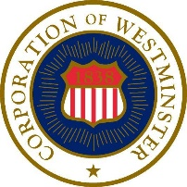

CITY OF WESTMINSTER

PUBLIC SAFETY COMMITTEE
OF THE MAYOR AND COMMON COUNCIL

MEETING AGENDA

Thursday, July 6, 2023, at 10:00 a.m.
45 West Main Street

- Call to Order – Chair Chiavacci

- Approval of Minutes – Chair Chiavacci
June 6, 2023

- Public Safety Updates

- Other Business

- Adjournment

